|  |  |
| --- | --- |
| NAME | ABHINAV KUMAR SINGH |
| ROLL NUMBER | 20IM30032 |

**ASSIGNMENT-2(OR LAB)**

1. Horsing Around makes horse saddles in both a child size and an adult size. Each child saddle requires 20 hours of assembly and 15 hours of finishing. Each adult saddle requires 30 hours of assembly and 10 hours of finishing. The company has a maximum of 300 hours available per week in the assembly department and a maximum of 150 hours per week in the finishing department. The profit for each child saddle is $255 and the profit for each adult saddle is $375. If the company wants to maximize their profit, how many child and adult horse saddles should be produced per week? What is the maximum profit?

Solution:

Formulation

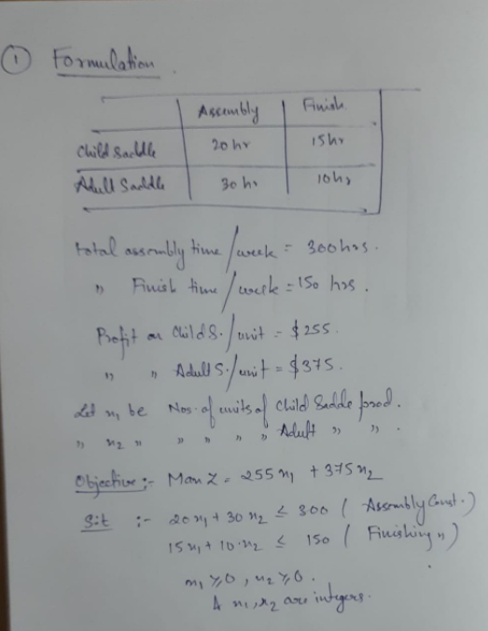

Model

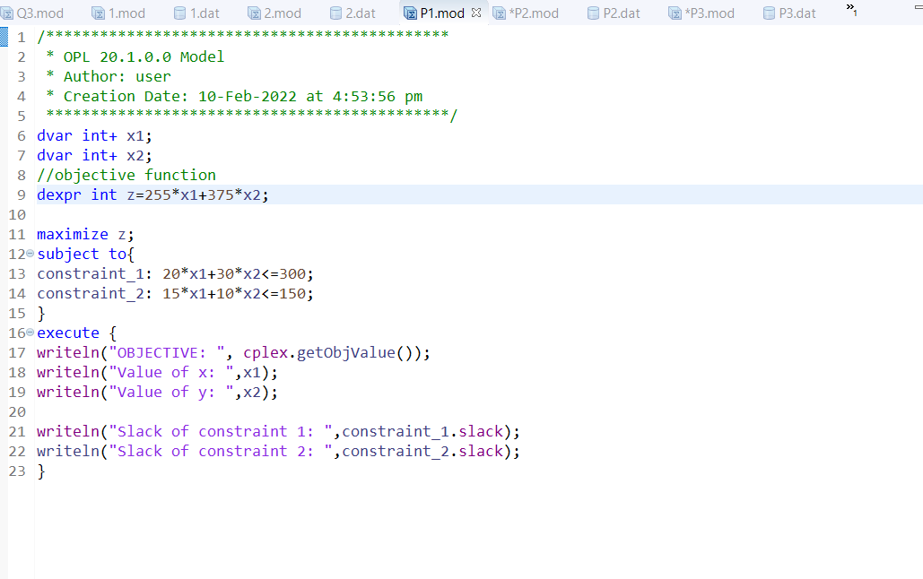

Problem Browser

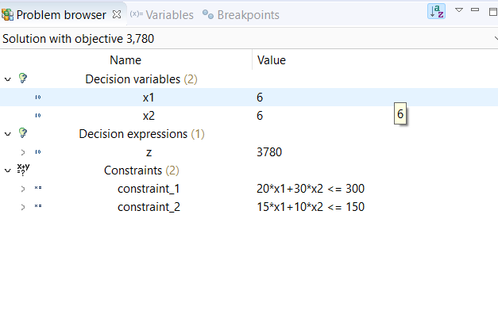

Scripting log

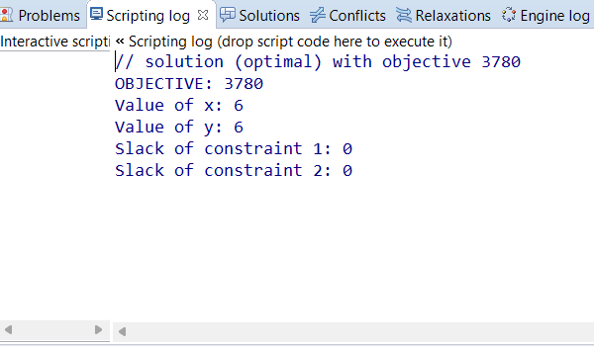

2. A transistor radio company manufactures four models A, B, C and D. Models A, B and C, have profit contributions of $ 8, $ 15 and $ 25 respectively and has model D a loss of $ 1. Each type of radio requires a certain amount of time for the manufacturing of components, for assembling and for packing. A dozen units of model A require one hour for manufacturing, two hours for assembling and one hour for packing. The corresponding figures for a dozen units of model B are 2, 1 and 2, and for a dozen units of C are 3, 5 and 1. A dozen units of model D however, only require 1 hour of packing. During the forthcoming week, the company will be able to make available 15 hours of manufacturing, 20 hours of assembling and 10 hours of packing time. Determine the optimal production schedule for the company.

Solution

Formulation

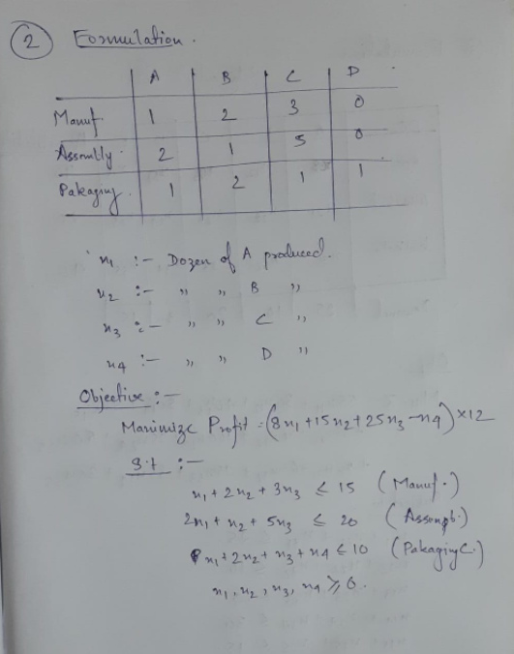

Model

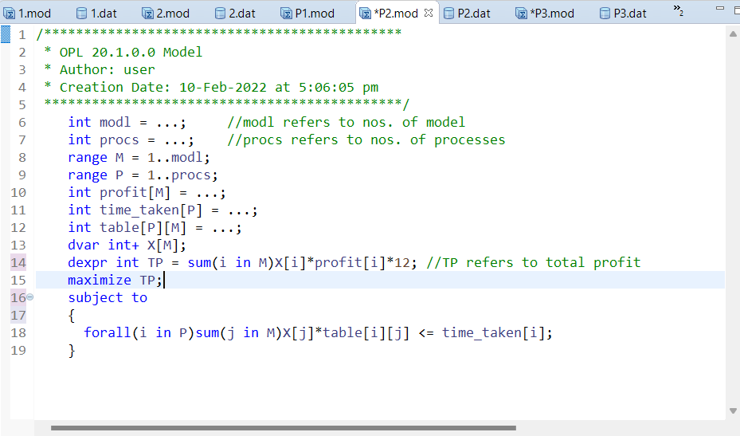

.dat file

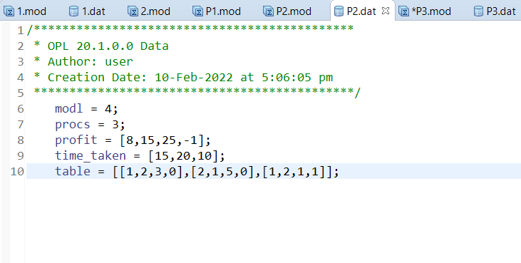

Problem Browser

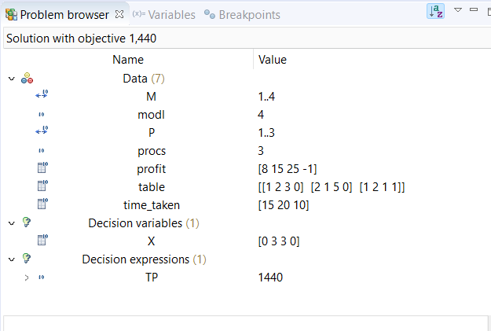

Solutions tab

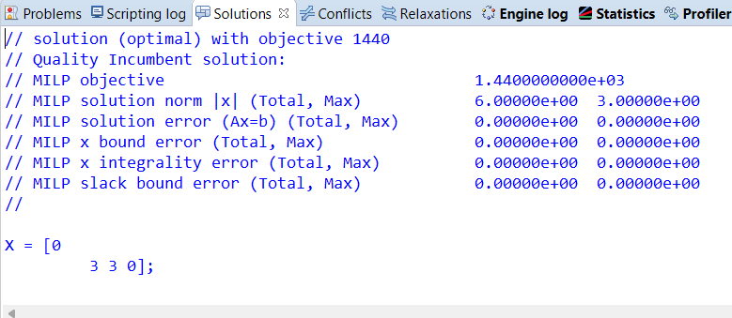

3. A manufacturer has distribution centers at Agra, Allahabad and Kolkata. These centers have availability of 40, 20 and 40 units of his product, respectively. His retail outlets at A, B, C, D and E require 25, 10, 20, 30 and 15 units of the products, respectively. The transport cost (in rupees) per unit between each center outlet is given below:

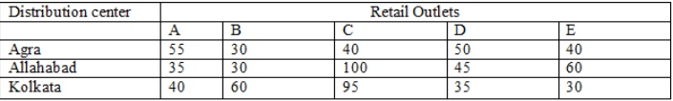

Determine the optimal distribution so as to minimize the cost of transportation.

Solution

Formulation

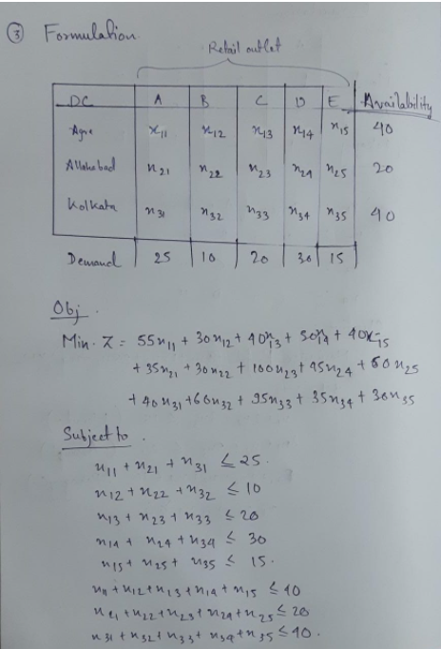

Model

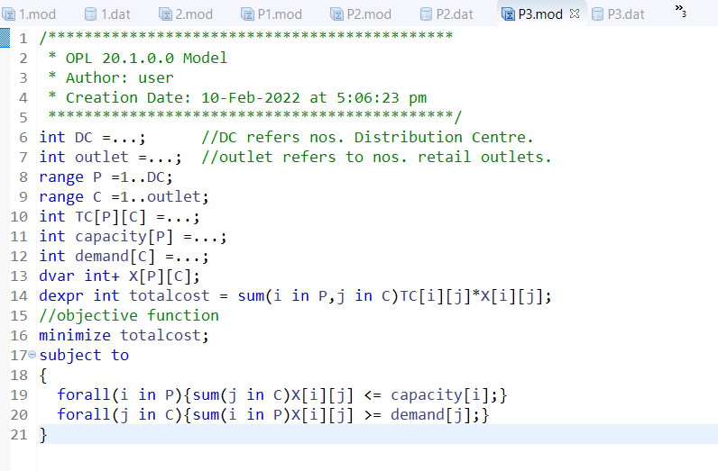

.dat file

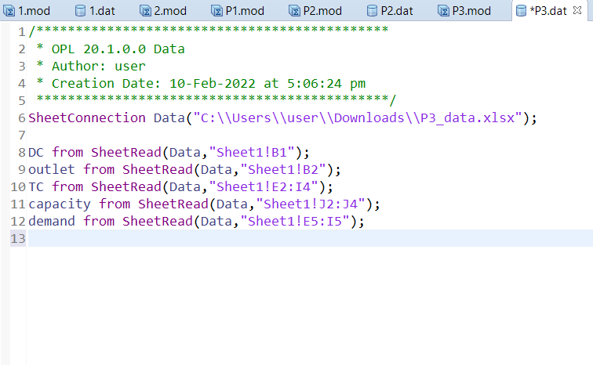

Excel sheet

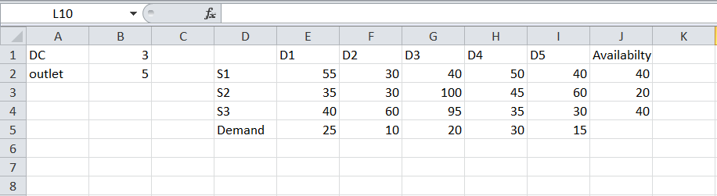

Problem Browser

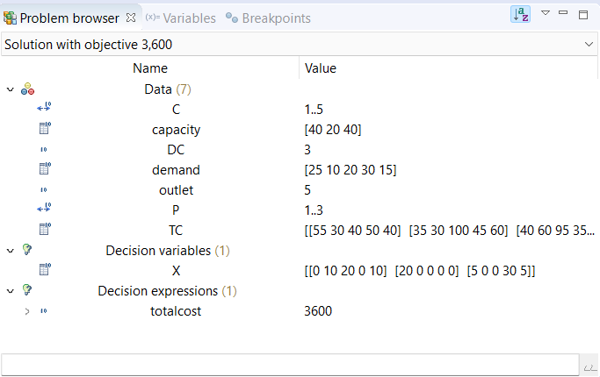

Solutions tab

